***Assignment – 9* Querying Multiple Tables at Once.**

1. Write a query that lists each order number followed by the name of the customer who made the order.

**select orders.onum,customers.cname from orders join customers on orders.cnum=customers.cnum;**

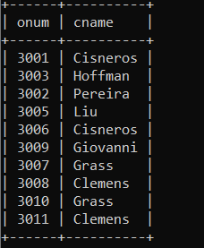

1. Write a query that gives the names of both the salesperson and the customer for each order along with the order number.

**SELECT Salespeople.sname, Customers.cname, Orders.onum**

**FROM Salespeople**

**JOIN Customers ON Salespeople.snum = Customers.snum**

**JOIN Orders ON Customers.cnum = Orders.cnum;**

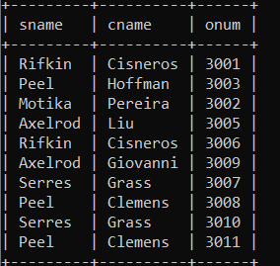

1. Write a query that produces all customers serviced by salespeople with a commission above 12%. Output the customer’s name, the salesperson’s name, and the salesperson’s rate of commission.

**select Customers.cname,Salespeople.sname,Salespeople.comm from Salespeople join Customers on Salespeople.snum=Customers.snum where Salespeople.comm>0.12;**

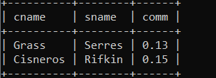

1. Write a query that calculates the amount of the salesperson’s commission on each order by a customer with a rating above 100.

**select O.cnum, O.amt,S.snum,(O.amt*S.comm) as "Commission" from Orders O join Customers C on C.cnum=O.cnum Join Salespeople S on O.snum=S.snum where C.rating>100;**

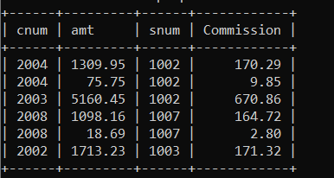

*Sameer Dehadrai* Page: 1